

**Physiotherapy**

**Telephone Triage Service**

# Do you have a muscle, bone or joint problem?



**Our Physiotherapy telephone triage service runs Monday to Friday: 0800 – 1200**

Please speak to a member of your GP reception team if you wish to be placed on the list for a call back to discuss your symptoms today.

**Please note**: The physiotherapist may call you back from a withheld or Southampton based phone number, so please answer if you are expecting their call.

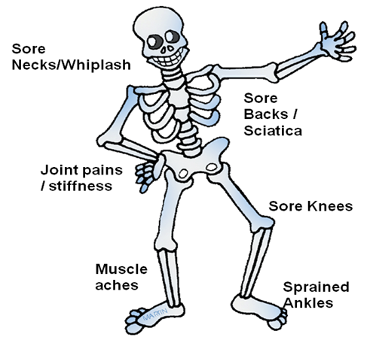

This service is brought to you by Solent NHS MSK Physiotherapy Service in collaboration with your GP Surgery:

**GP Surgery Contact Details:**

**Tel: _______________________**



**If the answer is YES:**

**The GP reception team can place you on a list for a physiotherapist to call you back the same day (between 0800 – 1200)**



*Leaflet produced: October 2018*

# What do we do?

A physiotherapist will call you to discuss your symptoms and decide on the best management

**How can we help?**

1. You may be offered advice, education and exercises over the phone.
2. You may be referred directly into the physiotherapy service for an assessment at either Queen Alexandra Hospital or St. Mary’s Community Campus.
3. You may be advised to complete a self-referral form to physiotherapy if your symptoms persist despite following the advice you have been given.
4. We may talk to you about pain relief and can discuss any additional medication with your GP if necessary.
5. We have access to our clinical physiotherapy specialist team if we feel any further investigations could be of benefit.

**Symptoms you may have:**

* Pain
* Tingling or numbness
* Stiffness
* Weakness

**The physiotherapy telephone service is not appropriate for:**

* Children < 16 years
* Pregnant *or* < 6 weeks post natal
* Patients requiring prescriptions **only** (i.e. not advice / assessment)
* Pain from other causes, not joint or muscular (ie. cardiac, systemic infection)
* Headaches
* Suspected infections
* Abdominal pain
* Chest / rib pain
* Undergoing active treatment for cancer
* Flare up of rheumatological conditions
* Swollen and painful calf area
* Non English speaking patients

You **do not** need to see your GP first in order to access the physiotherapy service in Portsmouth.

For an assessment, or a course of physiotherapy, you can self-refer using the following link:

[www.solent.nhs.uk/physioselfreferral](http://www.solent.nhs.uk/physioselfreferral)

**Did you know?**

The majority of joint or muscle related pain does not need to be assessed by a GP.

The physiotherapist will be able to guide you on the best person to see you for your symptoms.

This way you can access the most appropriate advice and treatment as early as possible and help you return to normal work and day to day activities sooner.

#### Physiotherapy

#### Physiotherapy Telephone Service